# Method 1：Burn by accessing the upper computer

1. it can be operated through MobaXterm (remote terminal login software)
2. find the IP address of the upper computer, which can be found on the screen or in the background of the router；

3. Then access this IP through SSH of the above software, as shown in the figure:

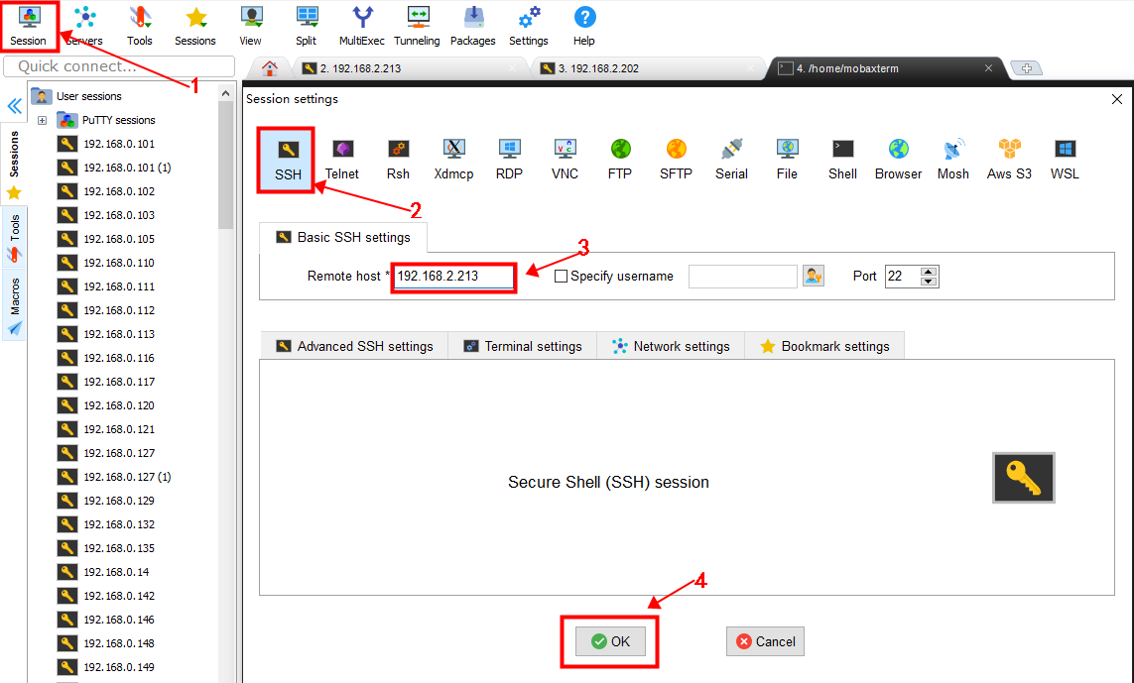

4. Enter the account and password of the upper computer, and then enter the command:

cd ~/klipper/

make menuconfig

Compile the firmware of the MMB module. The configuration is shown in the following figure:

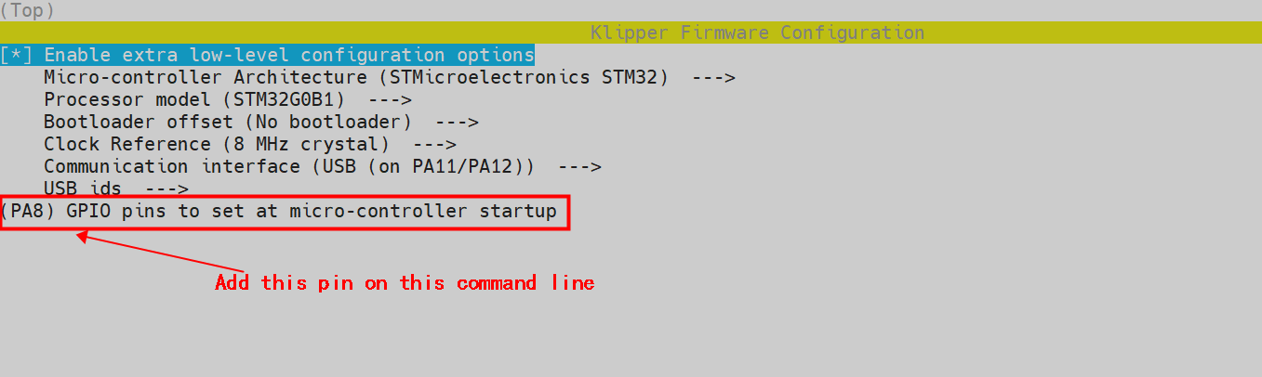

After completing the configuration selection, enter 'Q' to exit the configuration interface, and select 'yes' when asked whether to save the configuration;

1. Enter make to wait for the compilation to complete. The following message indicates that the compilation is complete, as shown in the figure:

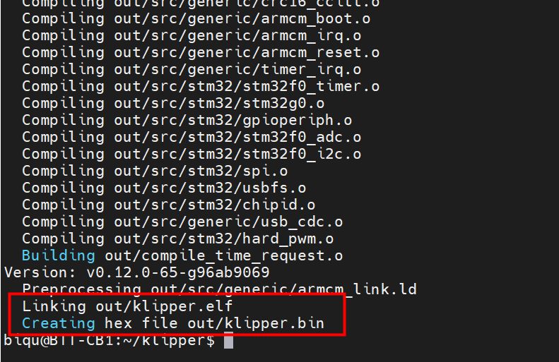

1. Plug the MMB module into the USB power supply jump cap, and then use the typec cable to connect the MMB module to the upper computer. Long press the BOOT key of the MMB module, and then click the RST key again. The module will enter the DFU mode and send the lsusb command to find the serial port of the DFU, as shown in the figure：

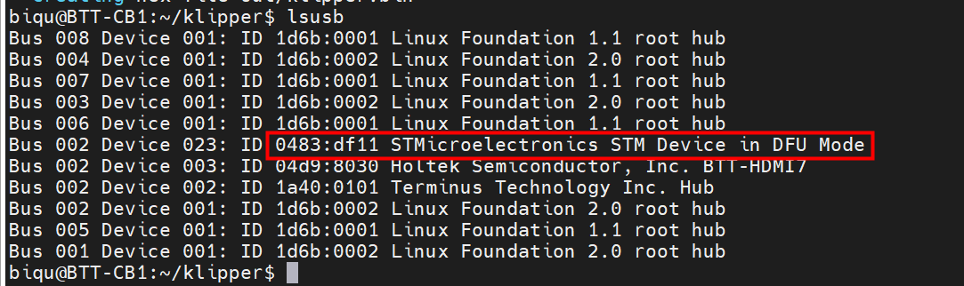

1. Send make flash flash_ Device=0483:df11 (Note: replace 0483:df11 with the actual device ID found in the previous step) update the firmware, as shown in the following figure：

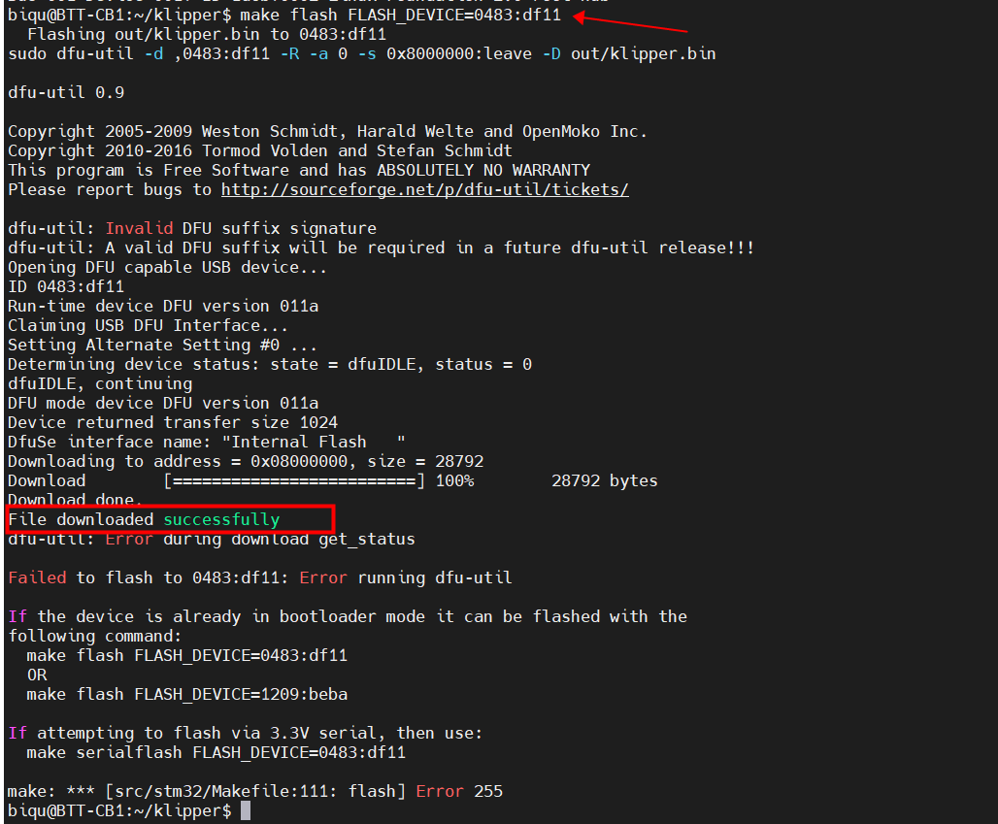

1. After the update is completed, send lsusb to see the serial port of the MMB module, as shown in the figure：

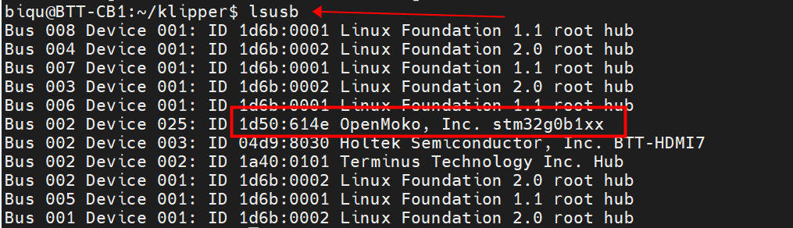

Note: to update the firmware in this way, you need to be in the Klepper folder directory, so if it is not in this folder, please send the CD Klepper command to enter the Klepper directory

# Method 2：Burn through STM32CubeProgrammer tool

# Download the stm32cubeprogrammer burning tool and install it;

1. In step 5 above, when make is completed, the 'klipper.bin' firmware we need will be generated in the home/pi/klipper/out folder. It can be directly downloaded to the computer on the left side of the SSH software (select this file, and then right-click to download), as shown in the figure below：

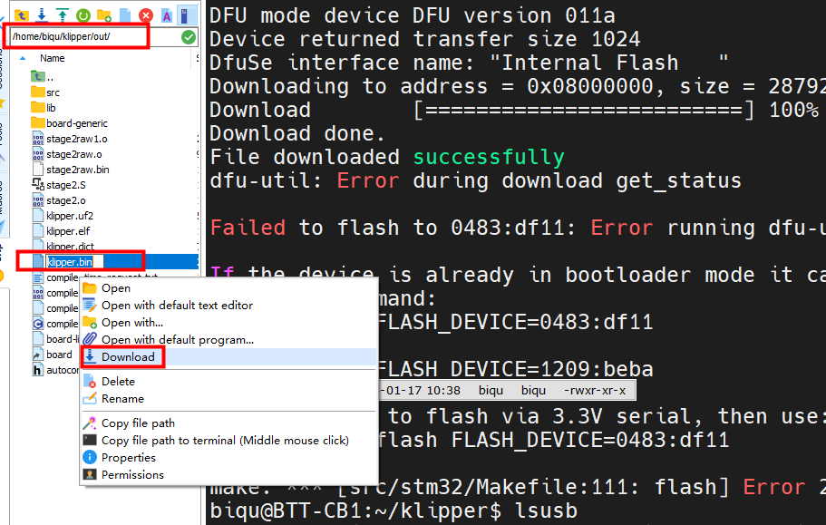

1. Open the stm32cuprogrammer burning tool, plug in the USB power supply jumper of the MMB module, connect the MMB module to the computer port through the Typec cable, long press the boot key of the MMB module, and then click the RST key again, the module will enter the DFU mode, and select the connection according to 123 in the picture：

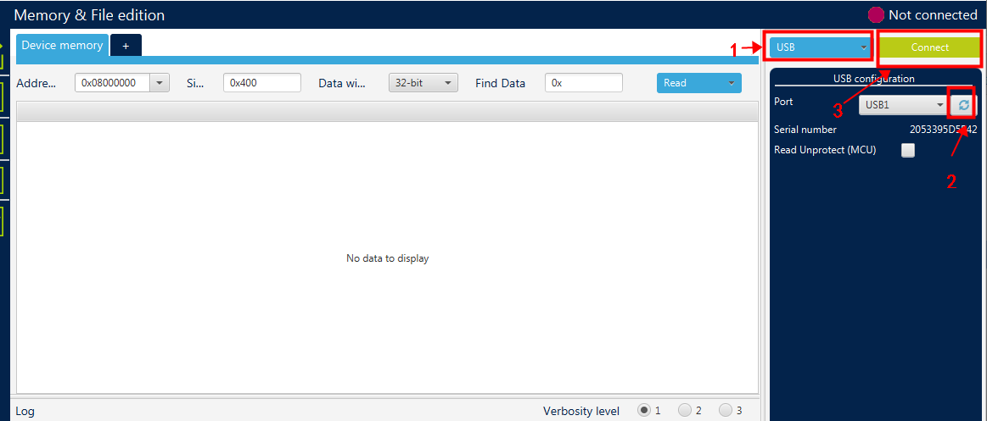

4. Then select the downloaded file according to 123 in the figure below, update and prompt to finish, as shown in the figure below：

